**Urban Company Data Analysis Report**

**Prepared by: Prachi Borkar**

**Date: 17th May 2024**

**Introduction:**

Urban Company, a leading provider of home services operating across multiple cities, offers a wide array of services to its clientele. This report conducts an in-depth analysis of Urban Company's data, focusing on service usage, revenue generation and city-wise performance metrics.

**Executive Summary:**

Urban Company’s data analysis provides an overview of key findings based on the limited dataset. Despite these constraints, I've successfully extracted **11 essential insights** into service performance and customer behavior, showcasing creativity, resourcefulness and strong analytical skills. The report delves into service usage, revenue generation and city-wise performance metrics, offering a range of actionable recommendations for optimization.

1. Most used services and subservices by city.
2. Expensive services and subservices used by top 5 cities.
3. 5 least used services by cities.
4. Least used services and subservices by cities.
5. Top 3 cities with the highest average charges
6. Percentage of services with additional labor charges by top 3 cities
7. Most common combination of service and subservice by city.
8. Average labor charges for different subservices in each city.
9. Percentage of services with higher labor charges than service charges by city.
10. Subservices With Higher Labor Charge Than Service Charge
11. Average charge exceeding the overall average charge across all cities

**Methodology:**

**Data Collection and Cleaning:**

* **Data Source:** The dataset was obtained from **Kaggle**.
* **Data Cleaning- Excel:** Data cleaning involved formatting, creating separate columns for sub-service charge and labor charge, and ensuring data consistency.
* **Analysis Tool- MySQL:** SQL queries were used to extract relevant information from the cleaned dataset.
* **Presentation Tool- Power BI:** For visualization and presentation, Power BI was utilized.
* **Interactive City Overview:** The Power BI dashboard allows users to select a city on the map, providing an overview of parameters such as service usage, sub-service details, charges and city.

**Data Overview:**

* **Dataset Size:** The number of records in the dataset are **8530**
* **Structure:** There are 7 columns are as below

1. **Service:** Represents the type of service provided by Urban Company (e.g., plumbers).
2. **Subservice Name:** Refers to specific subcategories or specialized services within the broader service category (e.g., “Wash Basin Leakage Repair” under plumbers).
3. **Sub Service Charge:** Indicates the cost associated with a particular sub-service.
4. **Sub Service Labor Charge:** Represents the labor cost associated with sub-service.
5. **City Name:** Identifies the city where the service was provided.
6. **Country Name:** Specifies the country where the service occurred (India in this case).
7. **Source:** Indicates the origin of the data (Urban Company).

**Key Findings:**

**Most Used Service and Subservice by City:**

* The analysis reveals the most utilized services and subservices across different cities.
* In Nashik, the service "Electricians" and subservice "Anchor Heavy/ Light Load Socket" emerges as the most used, with 3 requests.

**Expensive Service and Subservice Used by Top 5 Cities:**

* The top 5 cities with the highest total charges for services and subservices are identified.
* In cities like Cuttack, Rajahmundry, Madurai, Guntu and Meerut the service "AC_Service_Repair" and subservice "Compressor 2-ton" combination incurs the highest total charge of Rs. 9200.

**5 Least Used Services by Cities:**

* The analysis pinpoints the 5 least utilized services across cities.
* In cities such as Hyderabad, Ahmedabad, Rajahmundry, Vadodara, and Guntur the service "Microwave_Repair" is among the least used services, with 35 requests.

**Least Used Services & Subservices by Cities:**

* The report highlights the least used services and subservices in each city.
* In cities like Meerut, Madurai, Ranchi, Prayagraj, Amritsar, Gwalior and Kota, the combination of all services with different subservices such as "Fan Repair" and "Roller" exhibit the lowest usage with only 1 request. (For the complete list, please run SQL queries)

**Top 3 Cities with The Highest Average Charges:**

* The average cost of services, including labor charges, is calculated for the top 3 cities.
* Lucknow leads with an average cost of services at Rs. 1061.78, followed by Nashik at Rs. 889.82, and Hyderabad at Rs. 860.07.

**Percentage of Services with Additional Labor Charges by Top 3 Cities:**

* The percentage of services with additional labor charges is determined for each city.
* Lucknow tops the list with 37% of services incurring additional labor charges, followed by Nashik with 30%, and Dehradun with 28%.

**Most Common Combination of Service and Subservice by City:**

* The most frequent service and subservice combinations are identified for each city.
* Nashik: "Electricians" and "Anchor Heavy/Light Load Socket" are the dominant service-subservice pair, occurring 3 times.
* Agra: "Electricians" and "Bulb Holder Installation" are the most frequent service-subservice combination, appearing 2 times.
* Varanasi: "Electricians" and "3-Phase Changeover Switch Installation" emerge as the most common combination, also appearing 2 times.

**Average Labor Charges for Different Subservices in Each City:**

* The average labor charges for various subservices are calculated for each city.
* For instance, in Amritsar, the average labor charge for subservice "Replace LVT" is Rs. 499. (For the complete list, please run SQL queries)

**Percentage of Services with Higher Labor Charges Than Service Charges by City:**

* The percentage of services with higher labor charges than service charges is calculated for each city.
* In particular, 10% of services in Lucknow have higher labor charges than service charges. (For the complete list, please run SQL queries)

**Subservices With Higher Labor Charge Than Service Charge:**

* The query identifies subservices where labor charges exceed service charges across different cities.
* In Ahmedabad, the subservice "Adjust Grill Locks" has zero sub-service charges and a labor charge of Rs. 349. (For the complete list, please run SQL queries)

**Average charge exceeding the overall average charge across all cities**

* The top 10 cities with average charges higher than the overall average charge of all cities are identified.
* Lucknow has the highest average charges, exceeding the overall average by Rs. 224.84

**Insights & Analysis:**

**Service Usage Patterns:**

* The analysis of service usage across different cities reveals variations in customer preferences and demand.
* For instance, while some cities exhibit high demand for specific services like electricians or AC service repair, others show a preference for less common services such as microwave repair.

**Revenue Generation Trends:**

* Identifying the top revenue-generating cities sheds light on the geographic distribution of Urban Company's revenue streams.
* This information can guide resource allocation and marketing strategies to capitalize on high-demand areas and explore growth opportunities in underperforming regions.

**Cost Analysis and Profitability Insights:**

* Understanding the average cost of services and labor charges in each city provides valuable insights into cost structures and profitability margins.
* Cities with higher average service costs may indicate increased operating expenses or market dynamics influencing pricing strategies.

**Labor Charge Dynamics:**

* Analyzing labor charges, including the percentage of services with additional labor charges, offers insights into customer behavior and market competitiveness.
* Cities with a higher percentage of services with additional labor charges may indicate varying levels of competition or customer willingness to pay for premium services.

**Common Service-Subservice Combinations:**

* Identifying the most common service-subservice combinations provides insights into customer preferences and the popularity of specific service offerings.
* Understanding these patterns can guide service bundling strategies or marketing efforts to promote complementary services.

**Least Utilized Services:**

* Exploring the least utilized services and subservices uncovers opportunities for service diversification. Targeted marketing campaigns can increase awareness and demand.
* Understanding the factors contributing to low usage informs strategic decisions to either optimize or phase out underperforming services.

**Labor Charge Analysis:**

* Analyzing subservices with higher labor charges than service charges highlight pricing dynamics and customer expectations regarding service value.
* This insight guides pricing strategies and service package offerings to align with market expectations and enhance competitiveness.

**Geographic Disparities in Service Demand:**

* Variations in service demand and revenue generation across cities emphasize the importance of localized strategies and market insights.
* Tailoring services and marketing campaigns to meet the unique needs of each city enhances customer satisfaction and drives business growth.

**Recommendations:**

**Optimize Service Offerings:**

* Based on the analysis of service usage patterns and common service-subservice combinations, consider optimizing the service portfolio to align with customer preferences and market demand.
* This may involve introducing new services, bundling complementary offerings, or phasing out underutilized services.

**Strategic Pricing Adjustments:**

* Analyze labor charges and identify subservices with higher labor costs than service charges, then adjust pricing strategies accordingly.
* Consider implementing pricing tiers or promotional pricing to maintain competitiveness while maximizing profitability.

**Targeted Marketing Campaigns:**

* Leverage geographic disparities in service demand identified in the analysis to develop targeted marketing campaigns tailored to specific cities or regions.
* Focus on highlighting popular services, promoting seasonal promotions, or addressing gaps in service awareness.

**Resource Allocation:**

* Allocate resources based on revenue generation trends identified in the analysis.
* Prioritize investment in high-demand areas while strategically allocating resources to underperforming regions to stimulate growth.

**Customer Education:**

* Educate customers about less commonly used services highlighted in the analysis (e.g., microwave repair) to increase demand.
* Emphasize the value and benefits of these services through targeted communication channels.

**Geographic Expansion Opportunities:**

* Explore expansion opportunities in cities or regions with untapped market potential, indicated by low service usage or high revenue generation.
* Conduct market research to assess demand, competition, and regulatory considerations before expanding operations.

**Localized Strategies:**

* Tailor marketing efforts to meet the unique needs and preferences of customers in each city.
* Develop city-specific promotions, partnerships, or service bundles to enhance customer satisfaction and loyalty.

**Continuous Monitoring and Adaptation:**

* Establish mechanisms for ongoing data monitoring and analysis to track performance metrics and market trends over time.
* Regularly review and adapt strategies based on evolving customer preferences, market dynamics, and competitive landscape.

**Enhance Customer Experience:**

* Use insights from the analysis of labor charge dynamics and customer behavior to improve the overall customer experience.
* Invest in training programs for service professionals to ensure high-quality service delivery and customer satisfaction.
* Streamline service processes and prioritize customer feedback to continuously improve the overall customer experience.

**Conclusion:**

The analysis provides valuable insights into Urban Company's performance across different cities. By leveraging these insights, Urban Company can optimize resource allocation, tailor services to meet local demand, drive growth in revenue and profitability.

**Visualization:**

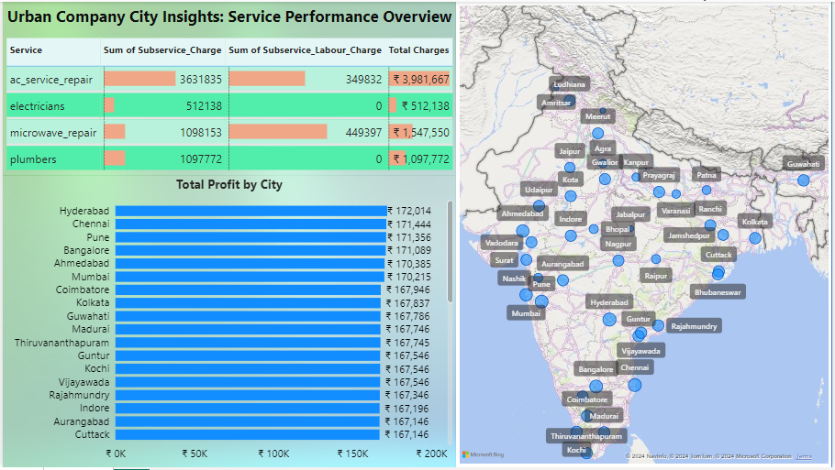

**Feedback and Further Analysis:**

Your feedback on this report is valuable for refining our understanding of Urban Company's performance and identifying areas for further analysis. Please feel free to reach out with any additional questions or analysis requests.